Template poster for the play street
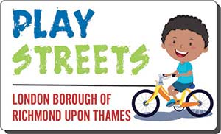

To celebrate Car Free Day on xx September 2022, xxx Road xxx are holding a Play Street between xxx and xxxx.

For more information call: xxxx
- Parents/carers are fully responsible for their children at all times during the play street
- The road will be closed and barriers will be put up
- Parked cars are still allowed on the road and residents should keep their speed to under 5mph if they need to access the road.
Find out more about Car Free Day here: www.richmond.gov.uk/play_streets

