Information Pack
Artists Make Space
Creative workspaces for artists
provided by Richmond Arts Service
_________________________________________________________________________
Contents:
- Summary & eligibility
- Artist role
- Arts Service role
- Frequently Asked Questions (FAQs)
- Appendix A – Spaces available
_________________________________________________________________________
Summary:
Richmond Arts Service invites arts organisations, artist collectives’ and individual artists living or working in Richmond Upon Thames to apply to our new Artists Make Space Programme. The selected artists, artist organisations or artist collectives will be supported with a space free of charge to practice their art, experiment with new creative techniques, hold meetings, etc. Artists who do not currently live or work in Richmond Upon Thames may apply if they are able to demonstrate that they will bring something innovative and exciting to the borough during their proposed residency.
Spaces on offer are located at:
- Orleans House Gallery, Twickenham
- The Old Town Hall, Richmond
- OSO Arts Centre, Barnes
We welcome applications from a range of practitioners looking to utilise our spaces across artforms including Music, Theatre, Dance, Visual Arts, Literature, and Combined Arts.
To be eligible for this programme, artists must have an existing practice and be aged 18 or older. We are keen to work with artists from a variety of backgrounds with different skills, stories, and experiences. We actively seek applications from our diverse communities including Global Majority, Deaf, disabled, neurodivergent, and LGBTQ+, to represent diverse lived experiences in our projects.
To apply, send a completed application form to artsinfo@richmond.gov.uk with the subject line Artists Make Space 2024 and your name. Applications must be received by Tuesday 30 April at 11.59pm.
_________________________________________________________________________
Artist role:
We want to work with artists who are committed to developing their practice, socially engaged, and reflect London’s diversity in the art and programmes they produce and the communities they engage.
The Arts Service encourages the artist(s) to:
- Help animate the space through their artistic practice.
- Commit to the programme and maximise the use of the space and opportunity throughout your period of occupation.
- Work with the Arts Service to share their involvement with the programme with the public e.g. through blog posts, open studio sessions, etc
- Participate in evaluation
- Engage with one or more of our core values, which are:
  - Collaborative – we work with people in innovative and inspiring ways, we invite artists, communities and individuals to create the public programme with us and help develop the arts service.
  - Socially engaged – we respond to the needs and wishes of local people, widen participation in the arts and connect people from different backgrounds, enabling them to have a say over issues that affect them, and promoting opportunity particularly for underrepresented groups.
  - Experimental – through the arts we test new ideas and approaches and share our learning to support the work of the borough. This might involve being playful, adventurous and taking risks.
_________________________________________________________________________
Richmond Arts Service's role:
The Arts Service will
- Provide studio / work / meeting space at no cost for the length of the agreement and will provide access to the space during agreed hours.
- Provide advice and assistance for the artist to raise additional resources such as grants to develop their practise (i.e., funding advice and consultation of up 2 hours)
- Provide an induction and make introductions so the artist can connect with relevant council staff as well as the creative sector locally and regionally.
- Help the artist develop an online method for promoting and sharing their Artists Make Space experience to reach wider audiences
- Provide one meeting quarterly with an Arts Officer to catch up, reflect and review on progress.
_________________________________________________________________________
Frequently Asked Questions (FAQs)
Can I apply for this artist opportunity at the same time as another opportunity you have live?

Yes!

Can I apply if I live outside the borough?

This opportunity is primarily for arts organisations, artist collectives’ and individual artists living or working in Richmond Upon Thames. Artists who do not currently live or work in Richmond Upon Thames may apply if they are able to demonstrate that they will bring something innovative and exciting to the borough during their proposed residency.

Can I apply if I live aboard?

No, this opportunity provides a working space only. It does not include living space or payment and therefore it is not suitable for artists who do not live within a commutable distance to the working spaces.

Can I visit the spaces?

Yes, but this will need to happen independently. We’re unable to accommodate site visits with a member of the team at this stage of the application.

What file-format should media be sent in?

Please send your completed application document and Curriculum Vitae as a PDF or Word document. If you are sending images, these can be sent as PDF documents, PNG images and JPEG/JPG images.

Here’s a list of additional file-formats we are able to receive: Windows Media formats (.asf, .wma, .wmv, .wm) Audio Visual Interleave (.avi) Moving Pictures Experts Group (.mpg, .mpeg, .m1v, .mp2, .mp3, .mpa, .mpe, .m3u) Musical Instrument Digital Interface (.mid, .midi, .rmi) Audio Interchange File Format (.aif, .aifc, .aiff) Audio for Windows (.wav) QuickTime Movie file (.mov) MP4 Audio file (.m4a) MP4 Video file (.mp4, .m4v, .mp4v, .3g2, .3gp2, .3gp, .3gpp)

Kindly note that we are unable to access applications sent as Pages documents, WeTransfer file transfers, Dropbox folders/links or Google Drive links.

When do I find out if my proposal has been accepted?

Successful applicants will be contacted by 28 May 2024.

_________________________________________________________________________

Appendix A – Spaces Available
Artists Make Space
Creative workspaces for artists
from Richmond Arts Service

Important:
This is a pilot year for the Programme, and we are open to your needs as artists. You may propose to use a space for a different amount of time or frequency if it is best for your practice.
_________________________________________________________________________
Spaces available:
- The Old Town Hall, Richmond
  - One-month and longer placements available beginning in spring 2024
- Workshop at Orleans House Galley
  - One-month placement available in autumn 2024
  - One-month placement available in early 2025
- Coach House at Orleans House Gallery
  - 6-12 month placement available weekly on Thursdays
- Training Room at Orleans House Gallery
  - One-week placement available in summer 2024
  - One-week placement available in early 2025
- Grounds of Orleans House Gallery (outdoors only)
  - One-week to 3-month placements available beginning in spring 2024
- OSO Arts Centre, Barnes
  - Eight-week placement, available two days a week beginning in autumn 2024 (Mondays 12pm – 3pm and Fridays 9am – 12pm)
_________________________________________________________________________
Details of each space:

The Old Town Hall, Richmond

Open Monday-Friday, 10am-5pm
Closed Sundays and Bank Holidays
One-month placements available beginning in spring 2024

Includes, at the artist(s) request: tables, chairs

Accessibility: The main entrance to the Old Town Hall is from Whittaker Avenue, up a flight of stone steps. The building has disabled access off Whittaker Avenue. The space comprises of 2 linked rooms on the ground floor of the Old Town Hall; the space is accessible from the central foyer and has an accessible toilet on the same floor.

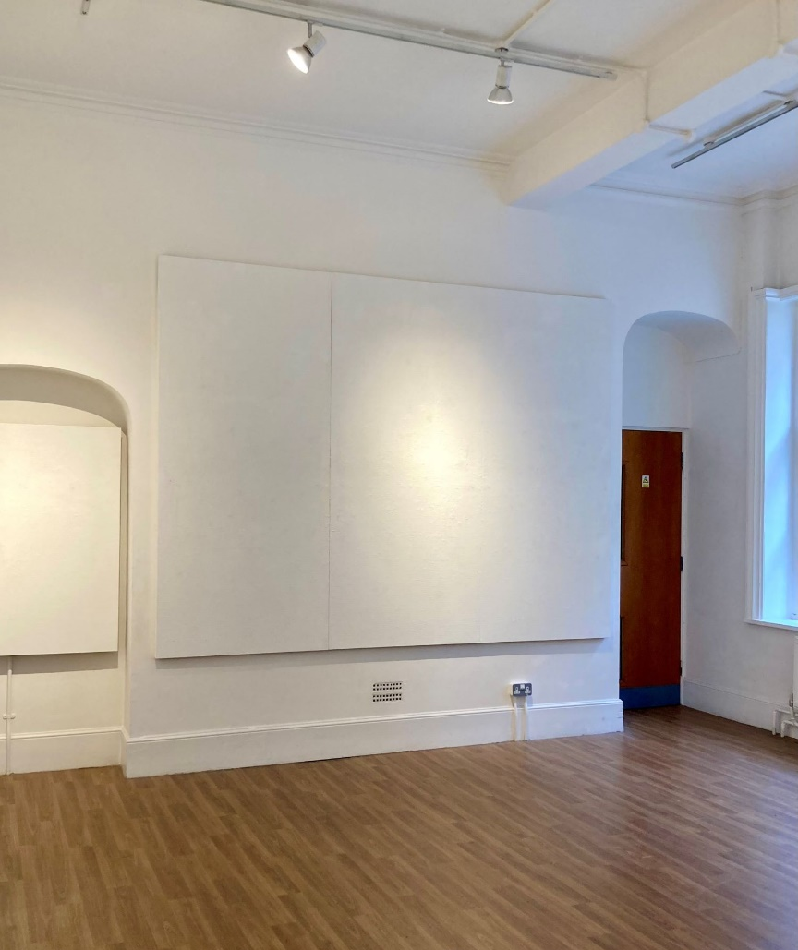
The space in the Old Town Hall Richmond
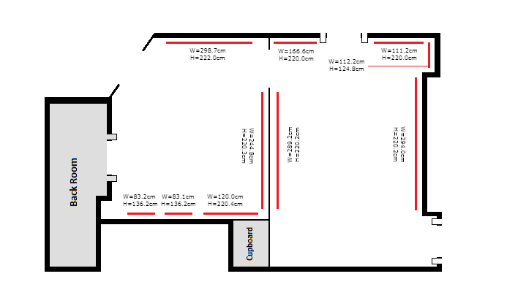
Floorplan of the space in the Old Town Hall Richmond
_________________________________________________________________________

Workshop at Orleans House Gallery
Open during the Gallery’s public opening hours, Tuesday – Sunday, 10am – 5pm
One-month placement available in autumn 2024
One-month placement available in early 2025

Includes, at the artist(s) request: An artist sink, storage for specialist materials and equipment, tables, chairs

Accessibility: The space is located on the Ground floor of the courtyard at Orleans House Gallery, and an accessible toilet is also on the same floor. The space may on occasion need to be accessed (upon agreement with the artist) by Orleans House Gallery staff for equipment.

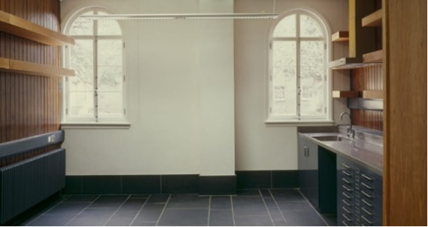
The Workshop at Orleans House Gallery

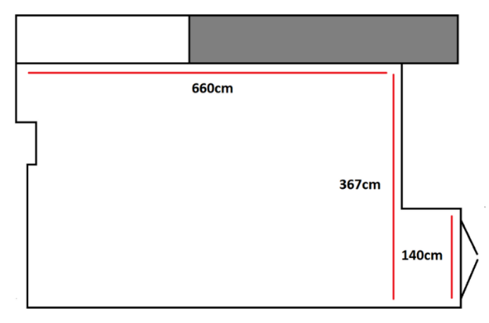
Floorplan of the Workshop at Orleans House Gallery
_________________________________________________________________________

Coach House at Orleans House Gallery
Available Thursdays, 10am – 5pm
6-12 month placement available on Thursdays

A large space that can accommodate up to 60 people

Includes, at the artist(s) request: audio-visual capabilities, large floorspace, tables and chairs, an artist sink, black out curtains/blinds, AV connection to large screen/projector
Integral sound system.

The room does not have a sprung floor but artists can provide one if necessary for their practice.

Accessibility: The space is located on the Ground floor of the courtyard at Orleans House Gallery, and an accessible toilet is also on the same floor.

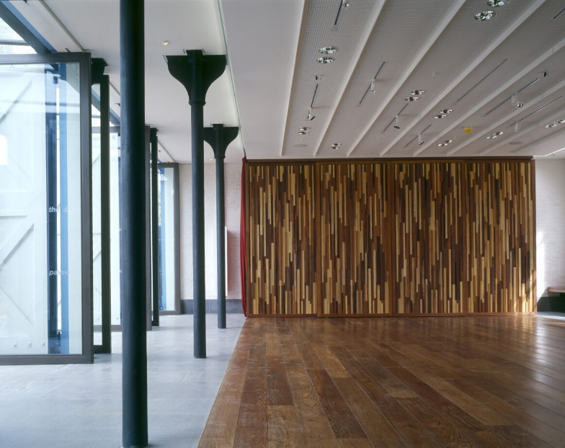
The Coach House at Orleans House Gallery, inside

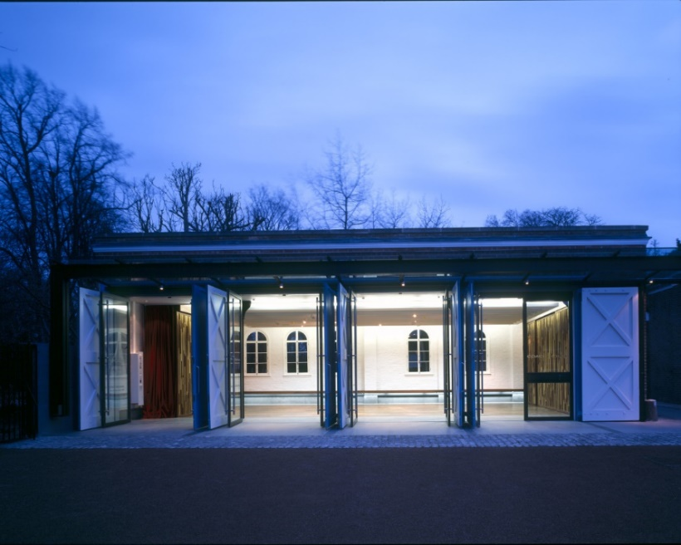
The Coach House at Orleans House Gallery, outside

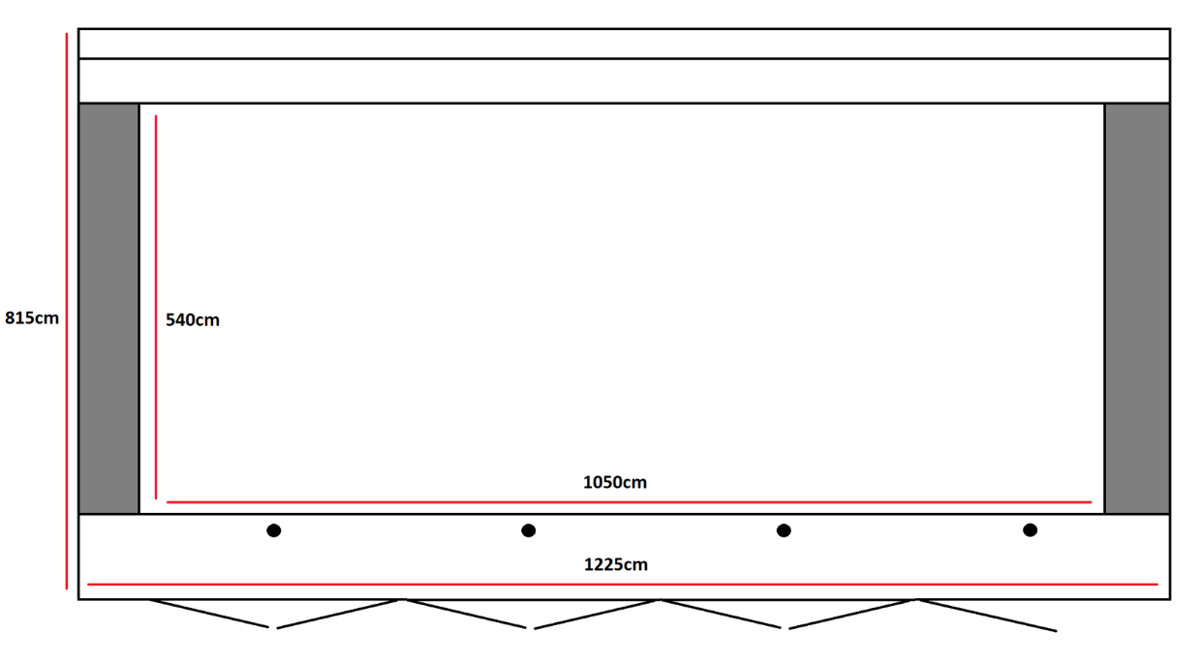
Floorplan of the Coach House at Orleans House Gallery

_________________________________________________________________________

Training Room at Orleans House Gallery
Open during the Gallery’s public opening hours, Tuesday – Sunday, 10am – 5pm
One-week placement available in summer 2024
One-week placement available in early 2025

A space that can easily accommodate up to 20 people.

Includes: Tables, chairs, and audio-visual facilities to accommodate high quality hybrid meetings and presentations.

Accessibility: The space is located on the 2nd floor at Orleans House Gallery, it is accessible by a lift and an accessible toilet is also on the 2nd floor nearby. There is also access to a small kitchen on this floor.

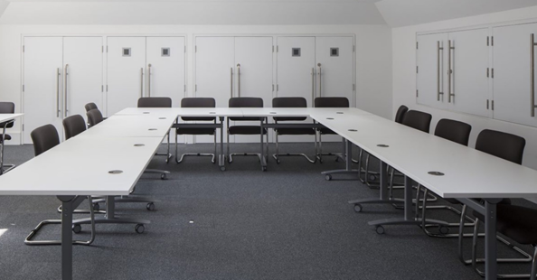
The Training Room at Orleans House Gallery
_________________________________________________________________________

Grounds of Orleans House Gallery
Open during the Gallery’s public opening hours, Tuesday – Sunday, 10am – 5pm
One-week to 3-month placements available beginning in May 2024

Woodland and front lawn suitable for outdoor practices.

Accessibility: The grounds and woodland cover uneven terrain. Some pathways along the grounds are paved. Paths in the woodland are not paved and can become muddy in rain.

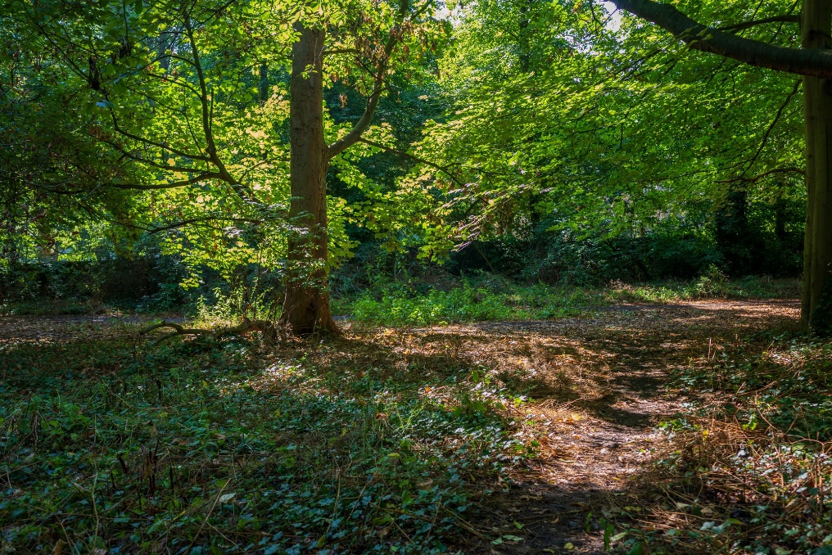

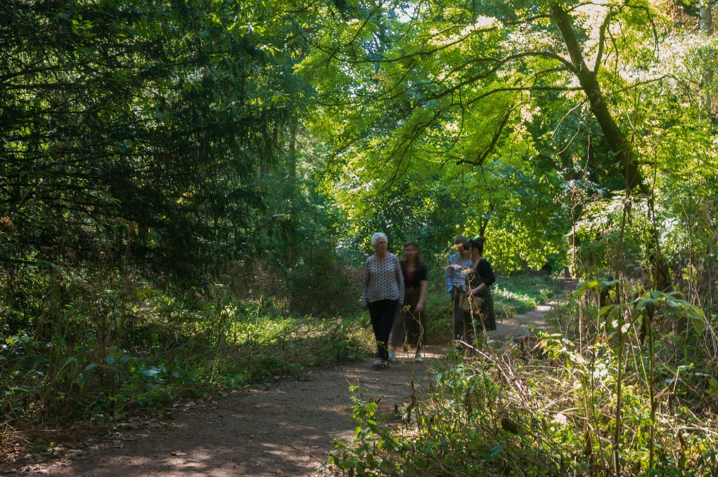
The Orleans House Gallery woodland, photographed by Eden Spence

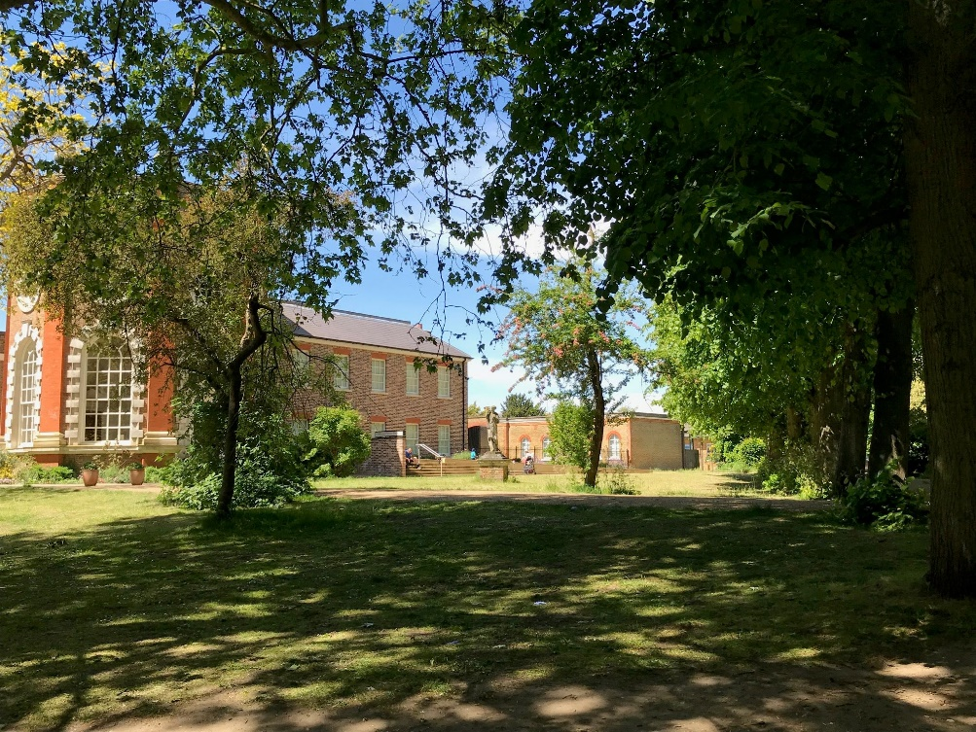
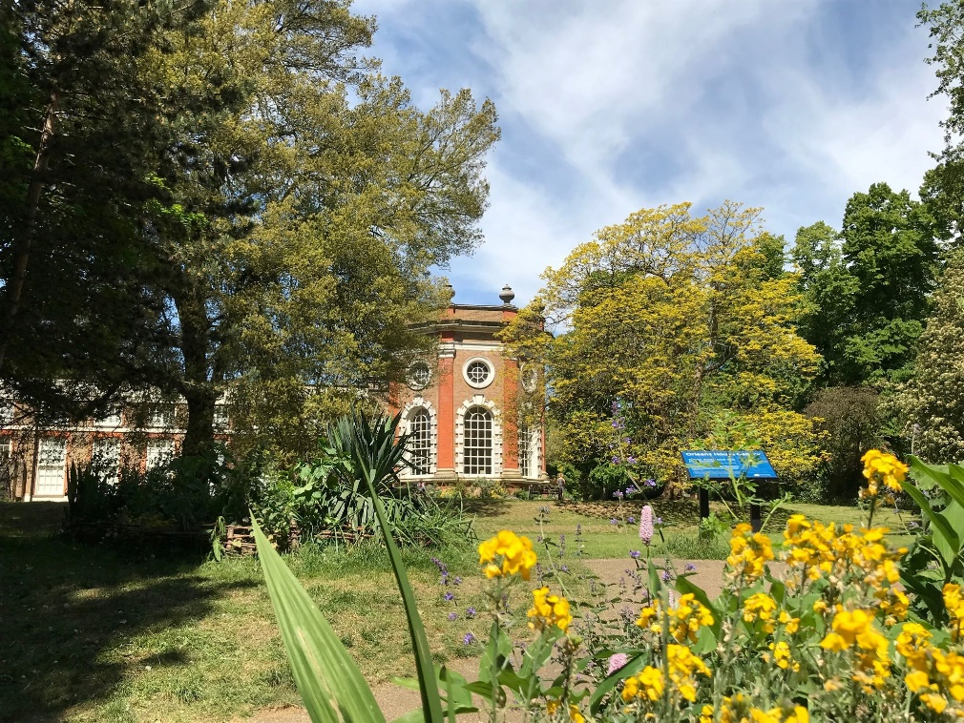
Orleans House Gallery grounds
_________________________________________________________________________

OSO Arts Centre, Barnes
Eight-week placement, available two days a week:
Mondays 12pm – 3pm and Fridays 9am – 12pm
Beginning 2 September 2024

Includes, at the artist(s) request: trestle tables, chairs

Accessibility: There is a ramp that leads to the automatic entrance doors at the OSO and the interior premises (including this space) are on one level, with access to accessible toilet facilities.

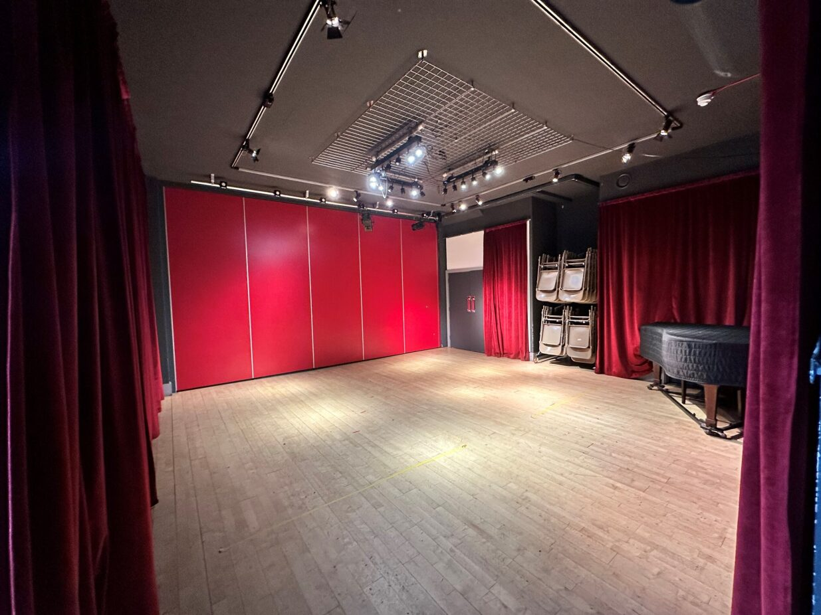
Space at OSO Arts Centre, Barnes
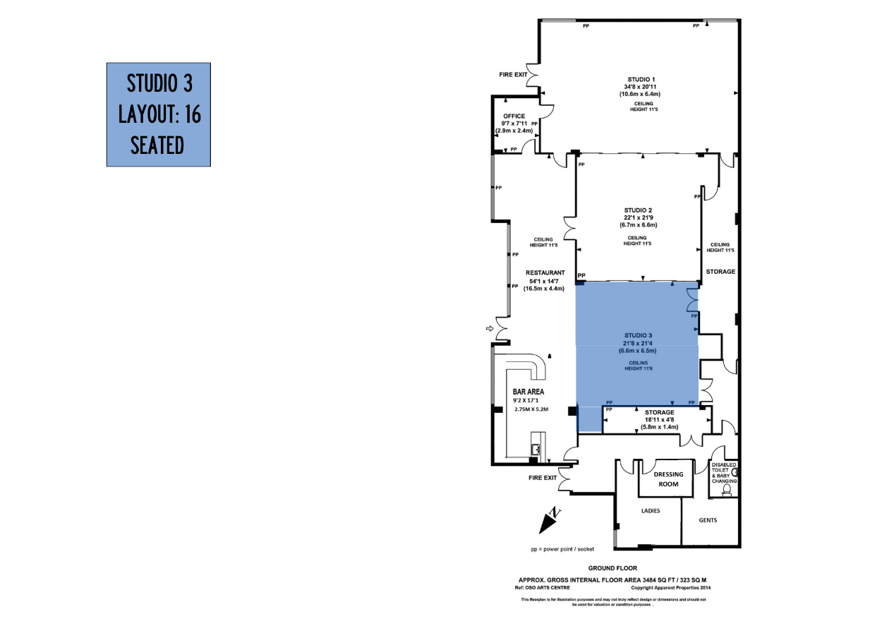
Floorplan of the space at OSO Arts Centre, Barnes

